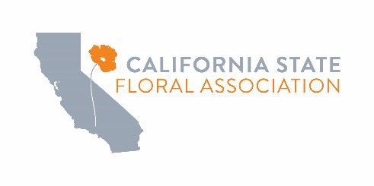

CaliFlora 2025 Student Design Competition Registration
Presented by The California State Floral Association
Friday, November 7, 2025
California State Fair, Sacramento, CA

Student Designer Entry Form

Yes, please reserve 1 space for the Student Design Competition on November 7th.
Registration fee $25.00 per person. A short bio is due with the entry form.

Contact Person:

Address

City: State:
Zip:

Phone:

COMPETITOR:
Email:

1.)
Name: School:

Address:

City:
State: Zip:
After October 25th All Prices Increase by $10 per event
Total Fees:
Registration: $________ $25.00 PER ENTRY
Total Due: $_________

Phone:
Email:

PAYMENT METHOD: If paying by credit card, a 3% processing fee will
be applied to your total.

□ Check payable to “CSFA”
□ Credit Card: ____ Visa ____ Mastercard ____ Amex

Card No. _________________________________________
Name on the card _________________________________
Exp. ______ Verify # ______ Signature: ____________________________

Name on card: __________________________________
(please print)

TOTAL AMOUNT TO CHARGE:__________________

California State Floral Association (CSFA) Cancellation Policy
If CSFA postpones or cancels your workshop we will provide you with as much advance notice as reasonably possible under the circumstance. Once you are notified of a workshop cancellation, you have the right to reschedule or request a refund. Please keep this policy in mind as you make travel arrangements, as CSFA will not be liable for travel costs. The following outlines CSFA’s cancellation policy: If you cancel a workshop 7 days prior to class start: No charges incurred. If you cancel 6 days or fewer prior to class start: You will be charged 100% of the class fee. If you register during the cancellation period, the policy is in effect immediately. If you are registered in a workshop and fail to attend, you will be charged 100% of the class fee.

Contributions or gifts to CSFA are not deductible as charitable contributions.

Please return this completed form by email (ann@agamsi.com) or mail to the CSFA office by October 25th. California State Floral Association, 1521 “I” Street, Sacramento, CA 95814 (916) 448-5266

